**Raul Alexandre Gonzalez Augusto RA: 211023698**

1. **Prints:**
   1. **Servidor:**

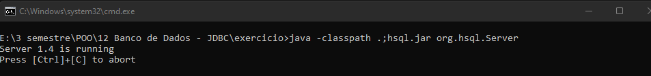

* 1. **Cria:**



* 1. **Insere:**



* 1. **Select:**

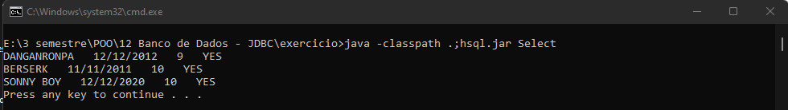

1. **Programas:**
   1. **Cria:**
2. import java.sql.*;
3. class Cria {
4. public static void main(String[] args) {
5. try {
6. Class.forName("org.hsql.jdbcDriver");
7. Connection con = DriverManager.getConnection("jdbc:HypersonicSQL:hsql://localhost:8080", "sa", "");
8. Statement stmt = con.createStatement();
10. stmt.executeUpdate("CREATE TABLE ANIMES (NAME VARCHAR(30), RELEASEDATE VARCHAR(30), SCORE INTEGER, WATCHED VARCHAR(30))");
11. stmt.close();
12. con.close();
13. } catch (Exception e) {
14. System.out.println(e);
15. }
16. }
17. }
    1. **Insere:**
18. import java.sql.*;
19. class Insere {
20. public static void main(String[] args) {
21. try {
22. Class.forName("org.hsql.jdbcDriver");
23. Connection con = DriverManager.getConnection("jdbc:HypersonicSQL:hsql://localhost:8080", "sa", "");
24. Statement stmt = con.createStatement();
25. stmt.executeUpdate("INSERT INTO ANIMES " + "VALUES ('DANGANRONPA', '12/12/2012', 9, 'YES')");
26. stmt.executeUpdate("INSERT INTO ANIMES " + "VALUES ('BERSERK', '11/11/2011', 10, 'YES')");
27. stmt.executeUpdate("INSERT INTO ANIMES " + "VALUES ('SONNY BOY', '12/12/2020', 10, 'YES')");
29. stmt.close();
30. con.close();
31. } catch (Exception e) {
32. System.out.println(e);
33. }
34. }
35. }
    1. **Select:**
36. import java.sql.*;
37. class Select {
38. public static void main(String[] args) {
39. try {
40. Class.forName("org.hsql.jdbcDriver");
41. Connection con = DriverManager.getConnection("jdbc:HypersonicSQL:hsql://localhost:8080", "sa", "");
42. Statement stmt = con.createStatement();
43. ResultSet rs = stmt.executeQuery("SELECT * FROM ANIMES WHERE SCORE BETWEEN 9 AND 10");
45. while (rs.next())
46. {
47. String name = rs.getString("NAME");
48. String release_date = rs.getString("RELEASEDATE");
49. int score = rs.getInt("SCORE");
50. String watched = rs.getString("WATCHED");
51. System.out.println(name + "   " + release_date + "   " + score + "   " + watched);
52. }
53. stmt.close();
54. con.close();
55. } catch (Exception e) {
56. System.out.println(e);
57. }
58. }
59. }